SECTION 3 BUSINESS APPLICATION

Completed applications should be submitted to:

[Grantee or Subrecipient Name]
Attn: Section 3 Program
[Grantee or Subrecipient Address]
[City, State ZIP]

If you have any questions on the application process Please contact the Section 3 Program
[Phone number and email]

Section 3 Business Application Checklist:
- Complete Section 3 Business Application
- Organizational Information
  - Articles of Incorporation or Organization (as applicable to business type)
  - Assumed Business Name Certificate
  - Certificate of Good Standing or Active status (as applicable to business type)
  - Partnership Agreement (if applicable)
  - Organizational Chart with Job Titles and Duties
  - Evidence of Business License
  - Other Applicable Documentation
- Qualifying Section 3 Criteria (Check applicable qualifying criteria below and include all requested supporting documentation)
  - 51% or more owned by low- or very low-income individual;
  - 51% or more owned by a resident of public housing; or
  - 75% of all hours worked over the prior three months worked by Section 3 workers
- Other Pertinent Information
  - Insurance Certificates
  - Current Financial Statement
  - Statement of Ability to Comply with Public Policy
  - List of all contracts for the past two years

W-9 (see last page of this application)

Name of Business

Physical Address

City, State, Zip

Mailing Address, if different

City, State, ZIP

Owner’s Name (Please include a copy of State ID or Driver’s License)

Telephone Number, including area code

Email

Date Company was established

ORGANIZATIONAL INFORMATION

All questions must be answered and the data given must be clear and comprehensive. If necessary, questions may be answered on separate attached sheet(s).

The company is a: □ Sole Proprietorship □ Partnership □ Joint Venture
- Corporation (please enclose a copy of corporation papers and corporate seal)
- Limited Liability Company (LLC)

General type of work performed by your Company (i.e. general contracting, HVAC, etc):

Are you minority owned (MBE)? Yes □ No □ Woman owned (WBE)? Yes □ No □
(Optional – For reporting purposes only)

Is this business licensed to operate in the certifying locality? Yes □ No □ (Enclose a copy if yes)
Please check and attach the following Business Entity documents, as applicable:
Copy of Articles of Incorporation Assumed Business Name Certificate Certificate of Good Standing Partnership Agreement Organization Chart with titles & duties Other Documentation

The Applicant must have at least the following insurance coverage for Section 3 contract work:
    - Commercial General Liability on an occurrence form for:
      - Bodily injury, and
      - Property damage liability
General Contractor limits of $2,000,000 combined single limit each occurrence covering the Project specifically, and umbrella excess liability of $5,000,000
Subcontractor limits will be $1,000,000 combined single limit occurrence, and $2,000,000 umbrella excess liability
    - Worker’s Compensation:
      - Statutory limits required by State Law
      - Employer’s Liability: $100,000
    - Comprehensive Automobile Liability
      - Bodily Injury: $1,000,000 Each Person
$1,000,000 Each Occurrence
      - Property Damage: $1,000,000 Each Occurrence

A copy of above insurance certificates must accompany this application. Coverage shall be maintained for the life of each contract or subcontract. Lapse of coverage may result in termination of contract and/or termination of approval to participate by the certifying entity.

The Applicant must have a satisfactory record of past work. Applicants with limited or no past
performance will be accepted on a “probation” basis, and will not be awarded more than one contract
at a time.

Please provide evidence of ability to perform successfully under the terms and conditions of other contracts:
- Current Financial Statement
- Statement of Ability to Comply with Public Policy
- List of all contracts for the past two (2) years

QUALIFYING SECTION 3 CRITERIA

The Applicant must satisfy at least one of the following minimum requirements to be qualified as a Section 3 Business Concern. Please check the appropriate box(es):

- At least 75% of all hours worked over the prior three-month period worked by Section 3 workers (attach supporting documentation)

- 51% or more owned by low- or very low-income individuals as determined by current HUD income limits for the area where the individual resides (https://www.huduser.gov/portal/datasets/il.html)

NAME & ADDRESS OF OWNER(S) | TITLE | % OWNER | ADJUSTED GROSS INCOME  (Attach current proof of income)

- 51% or more owned by residents of public housing

NAME & ADDRESS OF OWNER(S) | TITLE | % OWNER | PUBLIC HOUSING RESIDENT  (Attach current public housing lease)

Please sign the statement below certifying accuracy and authorizing the release of information to the certifying entity for the purpose of verifying your references. We have the right to request any additional information to validate information presented.

I certify that my answers are true and complete to the best of my knowledge. I hereby authorize the release of information to the certifying entity for the purpose of verifying my references.

Signature Date

FIELDS OF INTEREST AND EXPERIENCE
Please indicate the areas of interest and the length of experience within each capacity:

Construction-Related  Services | Interest | Length of  Experience | Non-Construction/Post-  Construction Services | Interest | Length of  Experience
Architecture |  |  | Appraisal Services
Bricklaying |  |  | Archeology
Carpentry |  |  | Building Inspection Services
Cement/Masonry |  |  | Building Maintenance
Demolition |  |  | Catering
Drywall |  |  | Computers/IT
Electrical |  |  | Courier Services
Elevator Construction |  |  | Engineering
Engineering |  |  | Janitorial
Environmental Services |  |  | Landscaping
Fencing |  |  | Legal Services
Flooring Installation |  |  | Management Consulting
Heating |  |  | Marketing/Photography
Insulation/Siding |  |  | Printing
Iron Works |  |  | Real Estate Services
Landscaping |  |  | Security
Machine Operation |  |  | Surveying Services
Painting |  |  | Transportation
Plastering |  |  | Other:
Plumbing |  |  | Other:
Roofing |  |  | Other:
Other: |  |  | Other:

What size of jobs in the areas indicated above are preferred?

Please list the suppliers with whom you do business (include the name, address and phone number):

Please list the Subcontractors with whom you regularly do business, if any, and indicate if they are Section 3 qualified*.

A. Carpentry: |  | Y/N
B. Electrical: |  | Y/N
C. Plumbing: |  | Y/N
D. Roofing: |  | Y/N
E. Masonry: |  | Y/N
F. Mechanical: |  | Y/N
G. Painting: |  | Y/N
H. Other: |  | Y/N
I. Other: |  | Y/N
J. Other: |  | Y/N

*Section 3 qualified businesses receive preference on federally funded projects

OTHER PERTINENT INFORMATION

Have you ever been convicted of violating Federal, State or Local Law in the course of discharging your

duties as a contractor? YES If yes, please explain:

NO

Have you ever been disbarred from participating as a contractor in any Federal, State or Local Housing program? YES NO
If yes, please explain:

Are you a licensed lead-based paint abatement contractor? YES NO
If yes, please provide a copy of all worker supervisor and contractor licenses.

Please complete and return the attached W-9 form (found on the last page of this application) along with this application.

REFERENCES

Name | Address | Phone number | Years Associated
Banks
Trades
Subcontractors

CERTIFICATION

I certify that all of the above information is correct and true to the best of my knowledge, under the penalty of law. I understand that this information will be used to determine my eligibility for the [Grantee or Subrecipient Name] Section 3 Program, which utilizes funds from the U.S. Department of Housing and Urban Development. The participating agencies do not discriminate against any person because of race, color, religion, sex, handicap, family status, or national origin. I understand that this application may be rejected if I withhold information requested or provide falsified information.

I understand that a Section 3 Business Concern certification is not an offer of employment. By signing this document I give the certifying entity permission to place my contact information on a list to be shared with businesses and community partners when they are hiring for Section 3 covered projects in the area. If awarded a HUD-funded contract, I agree to comply with all federal and local reporting requirements.

*Printed Name: *Title:

*Authorized Signature: _ Date:

*CORPORATE OFFICER OR PERSON AUTHORIZED TO SIGN BIDS AND CONTRACTS ON BEHALF OF THE COMPANY.

FOR INTERNAL USE ONLY

Date Application Received: Reviewed By: Date: Contractor: Does or Does Not qualify as a Section 3 Business Concern

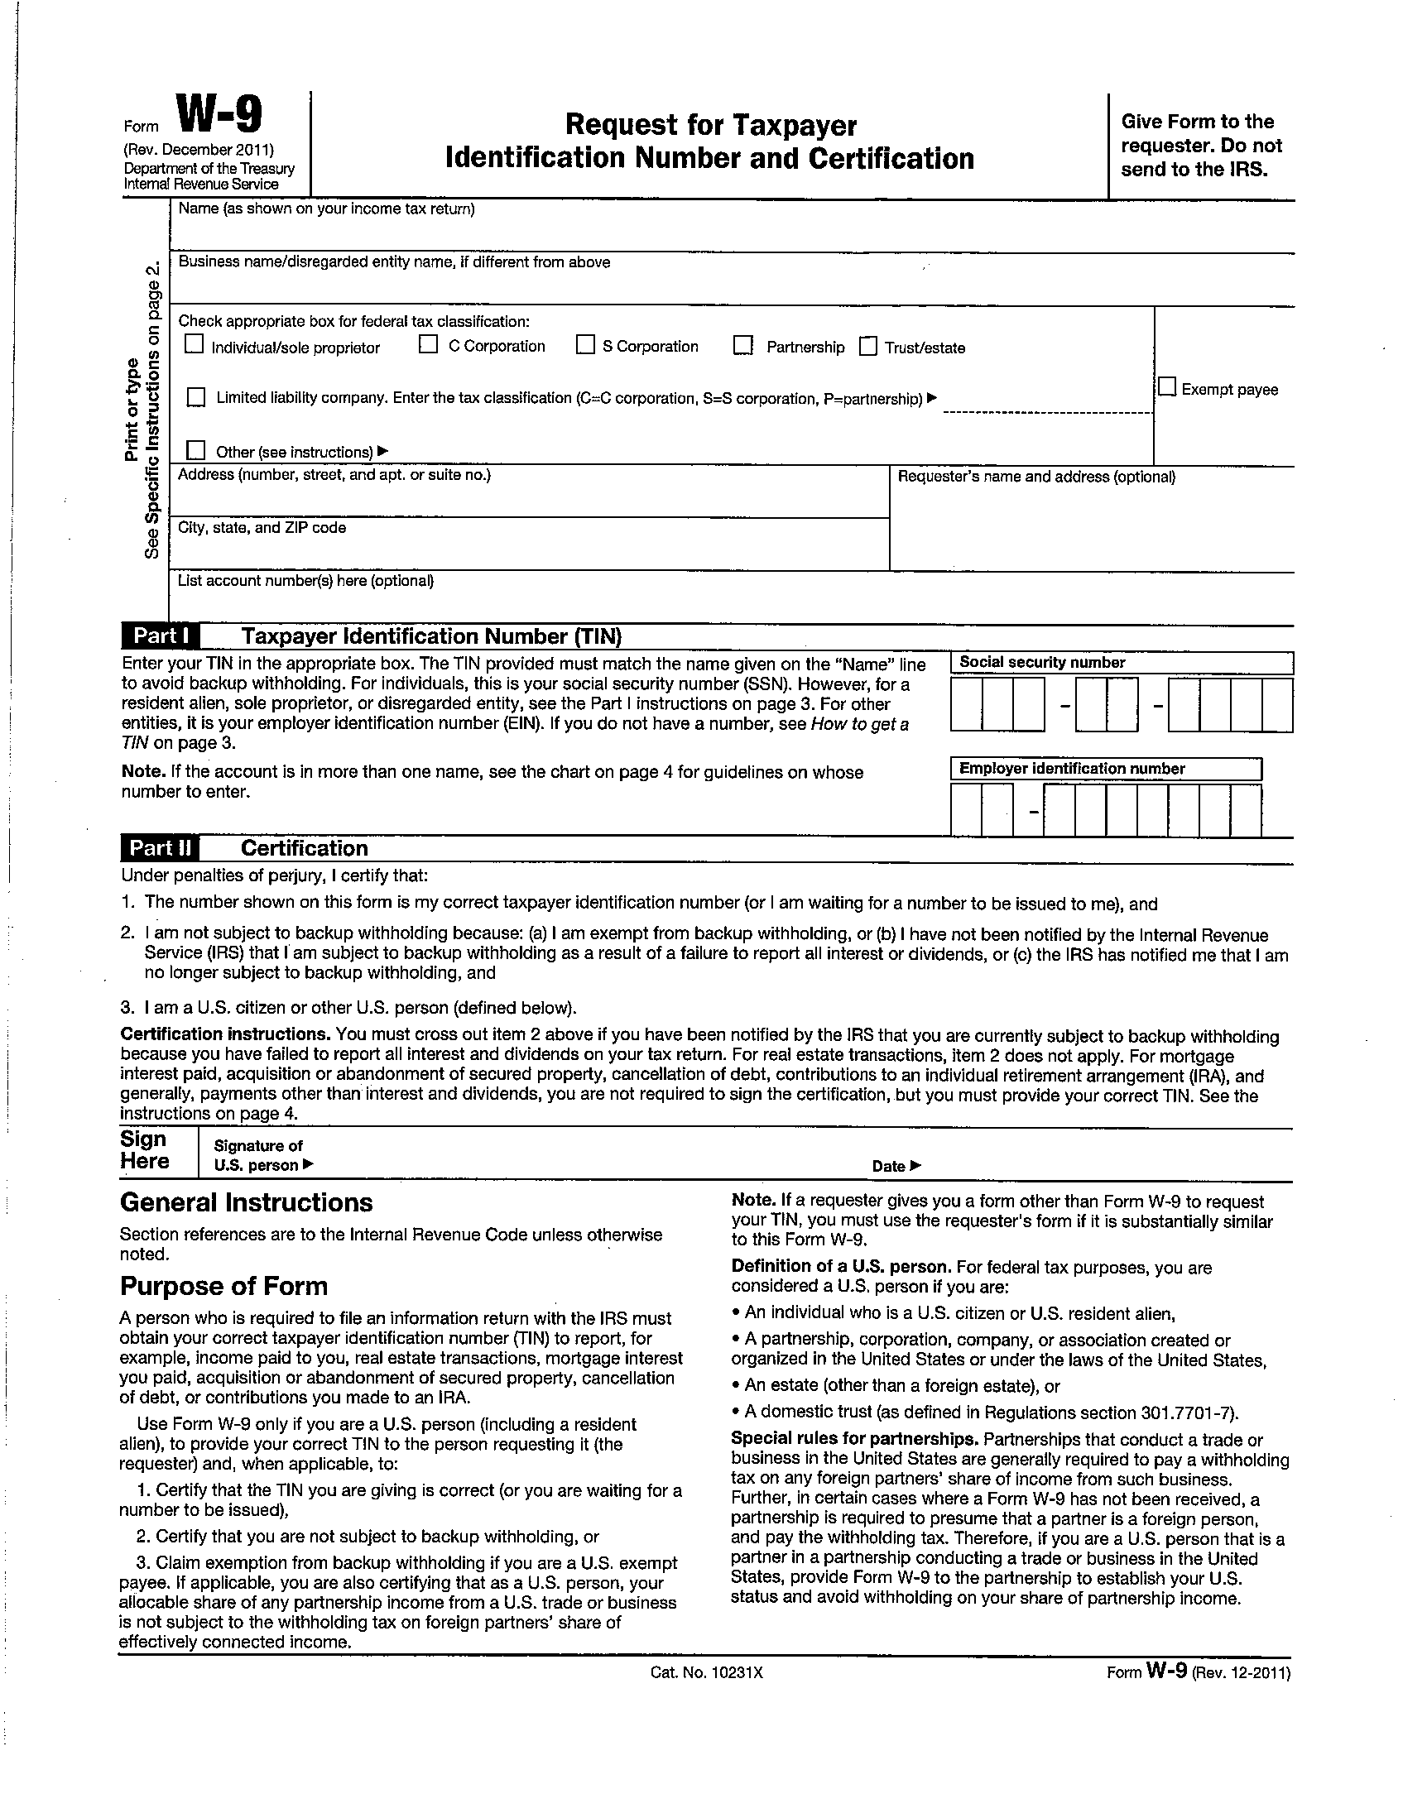

12

